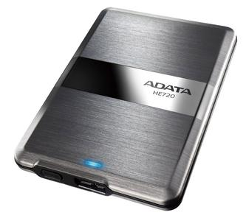

Adata DashDrive Elite HE720 (500GB)

If you store all your data in the cloud, it might be hard to fathom an external hard drive doing double duty as a status symbol. That's exactly what the sleek, wildly fast, and eye-wateringly expensive Samsung Portable SSD X5 is, though. Following in the footsteps of both Samsung's own flagship external drives like the Portable SSD T5 and design-forward works of hard drive art from LaCie and others, the X5 offers copious amounts of solid-state storage at extreme speeds, thanks to its use of the cutting-edge Thunderbolt 3 and PCI Express NVMe interfaces.

If you store all your data in the cloud, it might be hard to fathom an external hard drive doing double duty as a status symbol. That's exactly what the sleek, wildly fast, and eye-wateringly expensive Samsung Portable SSD X5 is, though. Following in the footsteps of both Samsung's own flagship external drives like the Portable SSD T5 and design-forward works of hard drive art from LaCie and others, the X5 offers copious amounts of solid-state storage at extreme speeds, thanks to its use of the cutting-edge Thunderbolt 3 and PCI Express NVMe interfaces. It would make a killer gift for Mac-bound video editors who shoot in 4K or photographers who work in RAW, but it's overkill for pretty much anyone else. If you store all your data in the cloud, it might be hard to fathom an external hard drive doing double duty as a status symbol. That's exactly what the sleek, wildly fast, and eye-wateringly expensive Samsung Portable SSD X5 is, though. Following in the footsteps of both Samsung's own flagship external drives like the Portable SSD T5 and design-forward works of hard drive art from LaCie and others, the X5 offers copious amounts of solid-state storage at extreme speeds, thanks to its use of the cutting-edge Thunderbolt 3 and PCI Express NVMe interfaces. It would make a killer gift for Mac-bound video editors who shoot in 4K or photographers who work in RAW, but it's overkill for pretty much anyone else.

SPEC DATA:

Type:
External

Storage Capacity (as Tested):
1 TB

Rotation Speed:
SSD

Ports:
Thunderbolt 3

